**To Write A Program In Mixed Language**

**Aim:** To find a gcd between two numbers in mixed language (C and Tasm)

programs

**Requirements:** Turbo C

**Theory:**

Programs can call programs that are written in other languages. This is referred to as mixed language programming. For example, when a particular subprogram is available in a language other than language you are using. Mixed-language programming always involves a call to a function, procedure, or subroutine. Mixed-language calls involve calling functions in separate modules. Instead of compiling all source programs with the same compiler, different compilers or assemblers are used as per the language used in the programs.

Microsoft C supports this mixed language programming. So it can combine assembly code routines in C as a separate language.

C program calls assembly language routines that are separately assembled by-MASM (MASM Assembler). These assembled modules are linked with the compiled C modules to get an executable file. Fig shows the compile, assemble and link processes using C compiler, MASM assembler, and TUNIC.

**Algorithm :**

1.      Start

2.      Declare 3 numbers a,b,gcd as integers.

3.      Move the a and b value to AX and BX respectively

4.      Repeat till AX!=BX step no 5 to 7 otherwise goto 8

5.      If AX > BX then goto step no 6 else goto step no 7

6.      Subtract AXß AX-BX

7.      Subtract BXßBX-AX

8.      Move AX  or BX to gcd variable

9.      Display the gcd.

10.  Stop

**Code :**

#include<stdio.h>

#include<conio.h>

void main()

{

int a,b,res;

clrscr();

a=12;

b=16;

asm mov ax,a

asm mov bx,b

bck:

asm cmp ax,bx

asm jc second

first:

asm sub ax,bx

asm jmp chk

second:

asm sub bx,ax

chk:

asm cmp ax,bx

asm jnz bck

asm mov res,ax

printf("The GCD is: %d",res);

getch();

}

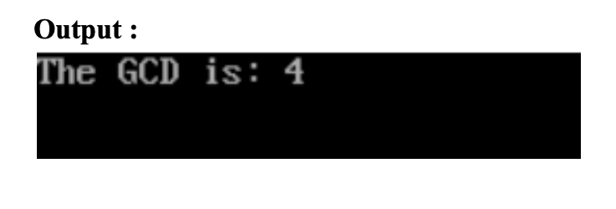

**Conclusion :**

Thus we were able to understand and write two mixed language programs using asm and c for adding two numbers and finding the gcd of two numbers using Turbo C.